Halloween Gift Bag
Traci Gardner (tengrrl@gmail.com)

Cardstock or DSP | - One 7" by 11" piece of Basic Black Cardstock  - One 3 ½" circle of Pumpkin Pie Cardstock  Decorations, as desired  - One ½" by 2 ¾" strip of Pumpkin Pie Cardstock  - Toil & Trouble 12" X 12" Designer Series Paper
Punch | Cat Punch  Gift Bag Punch Board
Stamp Set | “Trick or Treat” from Seasonal Chums, if desired
Ink | Basic Black, Stampin’ Chalk Marker, White Gel Pen (not SU), Red Gel Pen (not SU)
Embellishment | 12" Basic Black Solid Baker’s Twine, Wink of Stella, Googly Eyes (not SU)
General Supplies | Tear & Tape Adhesive, Glue Dots, Snail Adhesive, Bone Folder, Scissors
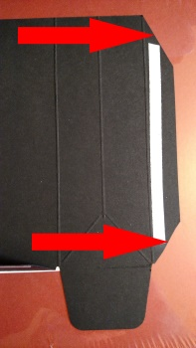
Preparing
- Use the Gift Bag Punch Board to cut the 7"by 11" Basic Black Cardstock, using the Medium bag score line.
- Trim the thin vertical flap diagonally, as shown in the photo on the right.
- Add Tear & Tape Adhesive, if desired.
Make Your Decoration
- Decide how you want to decorate your bag, using any of the available options (or your own design):
- Images fussy cut from the DSP
- Cats from the Cat Punch
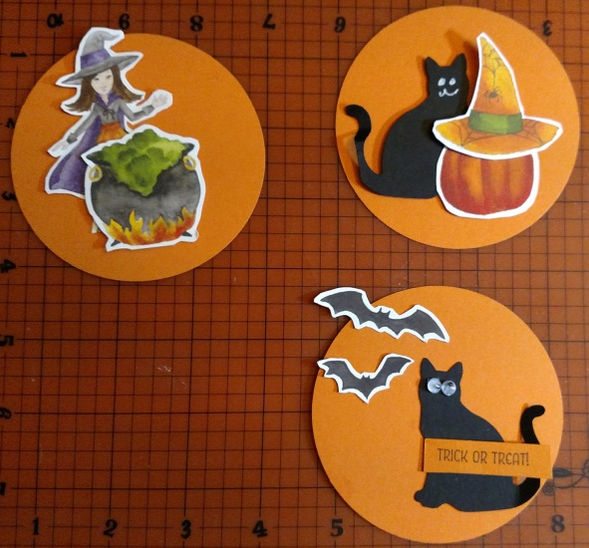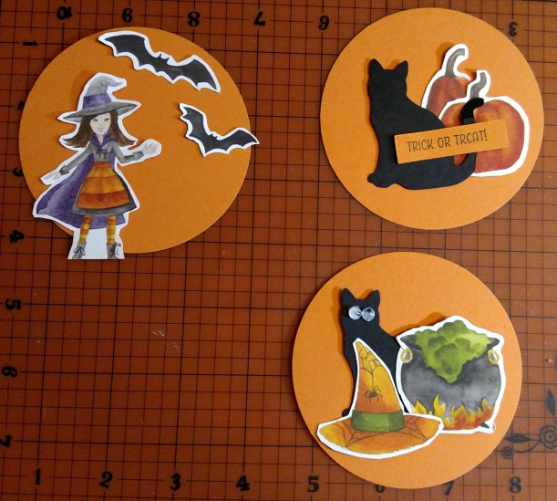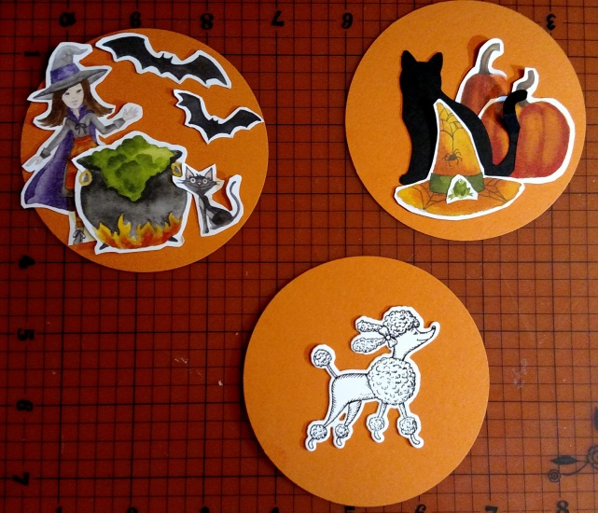
- Fussy cut whatever decorations you like from the Toil & Trouble DSP.
- Adhere your decorations to a 3 ½" circle of Pumpkin Pie Cardstock with Snail Adhesive.
Additional Ideas:
- If you want a face for your punched Cat, use the SU Chalk Marker, the White Gel Pen (not SU), or glue Googly Eyes (in the yellow M&M container with green polka dot paper) with Glue Dots.
- Stamp “Trick or Treat” on the ½" by 2 ¾" strip of Pumpkin Pie Cardstock,
OR stamp directly on the circle background.
- Draw eyes on bats with the Red Gel Pen.
- Highlight with Wink of Stella.
Assemble Your Bag
- Fold all score lines on the Basic Black base (the bag) and crisp with bone folder.
- Fold short flap to the inside of the bag, as shown, and remove the Tear & Tape backing:
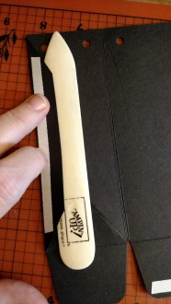
- Fold remaining portion of the bag in half, to meet the outside (folded) edge of the flap, as shown, and adhere:
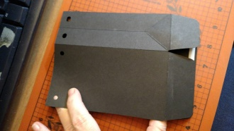
- Shape into open-ended bag, so that it looks like the photo below:
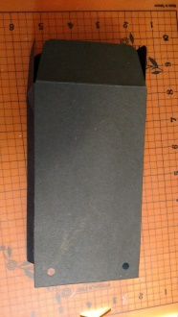
- Fold short flaps in, and then fold in the long flap without Tear & Tape, as shown. You can use additional adhesive if desired:
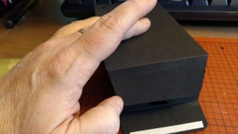
- Remove backing from Tear & Tape, and then fold up and adhere to other flaps to create bottom of the bag.
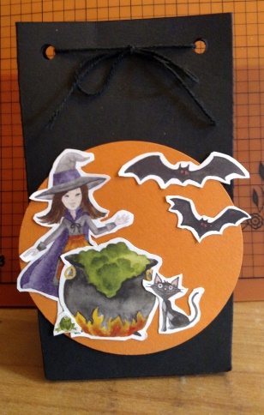
- Fold and shape into bag.
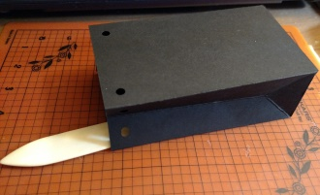
Finishing the Project
- Glue your decoration to the front of the bag with your favorite adhesive.
- Put your treat inside the bag.
- Cut 12" of Basic Black Solid Baker’s Twine.
- Thread the twine through the punched holes at the top of the bag and tie in the front.

